DataSoft

Nova Security Appliance User Manual
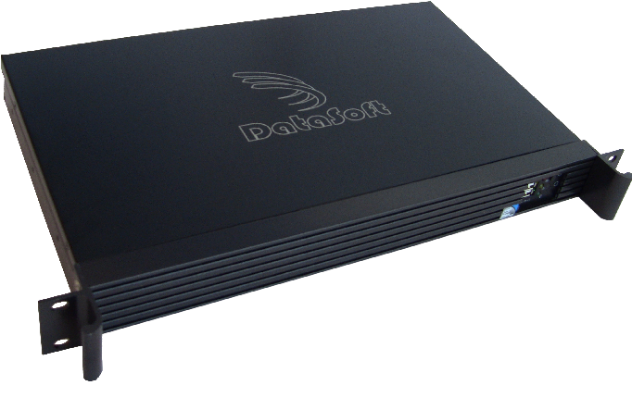

January 2013

Contacts

Technical Support
DataSoft Corporation
Address: 1275 W. Washington St., Suite 106, Tempe, AZ 85281
Phone: (480) 763-5777
Email: support@datasoft.com
Website: www.datasoft.com

Revision History

Revision | Date | Comments
1A | October 2012 | Initial Draft

Related Documentation
- Nova Security Appliance Quick-start Guide

Table of Contents
1.0 Introduction 5
1.1 What is Nova? 5
1.2 How do I access Nova? 5
2.0 Quick Setup Wizard 7
2.1 Accept Quick Setup Wizard 7
2.2 Create a New User Account 8
2.3 Edit Basic Options 8
2.3.1 Ethernet Interfaces 8
2.3.2 Doppelganger 9
3.0 Nova Status 10
3.1 Current Suspects 10
3.2 Hostile Events 11
3.3 Haystack Details 12
4.0 Haystack Settings 13
4.1 Presets 13
4.2 Autoconfiguration 14
4.3 Profiles 15
4.4 Nodes 16
4.5 Scripts 17
5.0 Configuring Nova 18
5.1 Basic Configuration Options 18
5.2 Advanced Configuration Options 20
5.3 Interface Aliases 21
5.4 Whitelist 22
6.0 Training 23
6.1 Training Data 23
7.0 Logs 24
7.1 Nova Logs 24
7.2 Haystack Log 25
8.0 Users 26
8.1 New User 26
8.2 Edit User 27
9.0 Documentation 28
9.1 About 28

Index of Figures
Figure 1: Initial Configuration of Quasar will have a self-signed TLS certificate 6
Figure 2: Initial Login to Quasar 6
Figure 3: Nova Introduction Page 7
Figure 4: Suspects Page 8
Figure 5: Hostile Events Page 9
Figure 6: Haystack Status 10
Figure 7: Basic Configuration 16

Introduction

What is Nova?
Nova is a Free Software tool for network security, it helps you to keep your private network private. Specifically, Nova is an anti-reconnaissance system. This means it has two principle features:
- Prevent Hostile Reconnaissance
- Detect Hostile Reconnaissance
Prevention is done by applying a large array of fake decoy virtual machines (called the “Haystack”) to the protected network. These virtual machines may be unlike others you're used to, however. They are “Low Fidelity” honeypots, meaning that they do not fully emulate the machine they are pretending to be. They only appear real from the perspective of someone out on the network. This gives Nova the ability to pretend to be any* type of machine, and emulate thousands of them at the same time. Other characteristics of these fake machines can also be set: Open and closed ports, services running on those ports, uptime values, Ethernet addresses, etc... For more information about setting these configurations, see Section 4.
Detection of hostile reconnaissance is accomplished by using an assisted machine learning algorithm. Having the Haystack applied to your private network gives Nova an important advantage: they are decoys. Benign network nodes should not be contacting the decoys, and they certainly shouldn't be contacting thousands of ports on all of the decoys. Thus, traffic going to the Haystack is presumptively hostile, and lets us feed this information back into the system for automated classification. Specifically, Nova uses k-NN (k Nearest Neighbors) to perform the statistical classification. For more information about classification, see section 3.1.

* Any Operating System in the nmap-os-db (Nmap's OS Database) can be made using Nova. Which is quite a lot, in practice.

How do I access Nova?
The primary user interface that you will be accessing is Nova's Web UI, called Quasar. This design lets you use Nova from nearly any computer on your network, regardless of platform. For best results, use Firefox or Chrome browsers. Internet Explorer may function, but it is not recommended. Nova uses Javascript to display much of its data, so you will need to have Javascript enabled when viewing its pages.
Quasar will, by default, run on TCP port 8080 over HTTPS. Thus in order to access the interface, follow this URL from your browser...
https://YOUR_IP_ADDRESS:8080
… where “YOUR_IP_ADDRESS” is obviously the IP address of the appliance on your network. You may initially be prompted with a TLS certificate error, such as shown in Figure 1:

Do not be scared by this warning, it is just due to the fact that Quasar requires an HTTPS connection (no insecure HTTP). But obviously, there will be no way to provide a TLS certificate for the IP address that the Nova Appliance will use on your private network. Therefore, you will have to temporarily use this invalid TLS certificate. The option will be given to you later to replace it with your own trusted certificate.
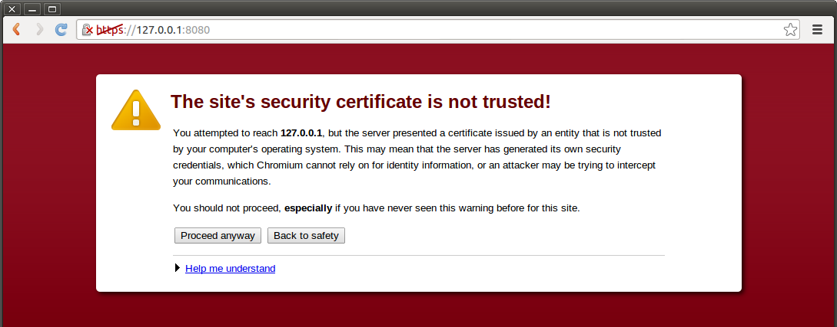Figure 1: Initial Configuration of Quasar will have a self-signed TLS certificate
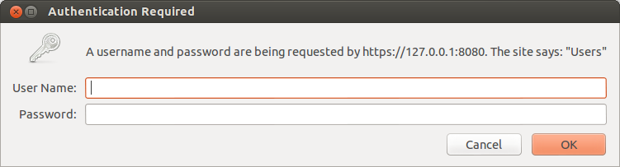Figure 2: Initial Login to Quasar
Next, you will have to log in to Quasar using a default username and password as seen in . The initial login credentials for your Nova Appliance can be found on a sticker on the top of the hardware. For obvious reasons, it is advised that you change this username and password after this first login, which is explained later in Section 8.
After logging in, you should see the Quasar welcome page as shown in Section 2. Now you're all ready to get your Nova Appliance set up and running. Continue on to Section 2 to continue with the Quick Setup Wizard.

Quick Setup Wizard

Accept Quick Setup Wizard
Upon your first login, Nova will ask you if you would like to execute the Quick Setup Wizard. This wizard will step you through all the important initial settings that you need to get started when you first run your Nova Appliance.
Options:
- Follow the Quick Setup Wizard
- Do not follow the Quick Setup Wizard, and don't prompt me again
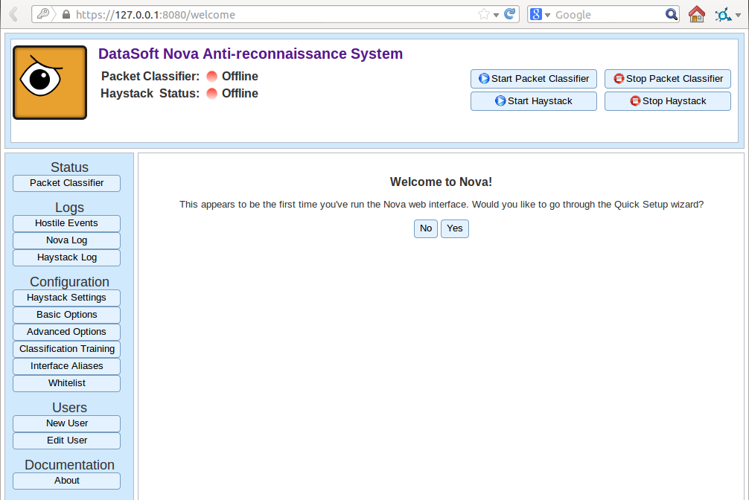Figure 3: Nova Introduction Page

Create a New User Account
The default username and password for your Appliance can be found on a sticker on the Nova Appliance hardware itself. It is highly recommended, however, that you change this initial login. The Quick Start Wizard will prompt you to do this now, as shown in Figure 4. Enter your new desired username and password into the fields, and press “Continue to Basic Options”.
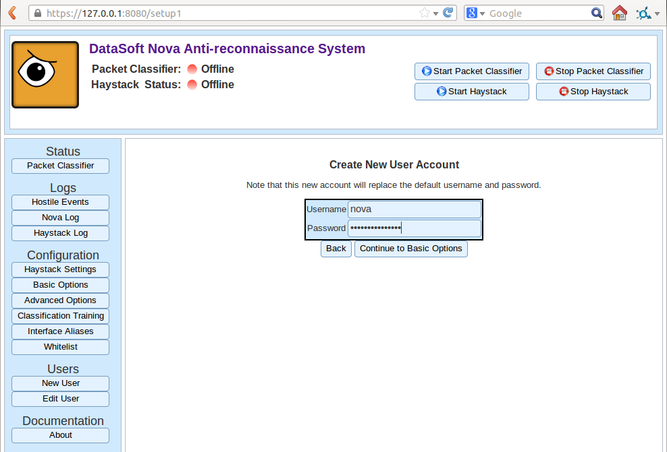Figure 4: Creating a New User Account

Edit Basic Options
The next page, shown in Figure 5 has a few options that you can choose to set. Let's walk though them now.

Ethernet Interfaces
This is where you can select which of the available Ethernet Interfaces on your Nova Appliance will be used to listen on during operation. The default setting is to listen on all available interfaces. If you wish, however, you can select any subset of these to actually use.
NOTE: There is no adverse effect to performance by selecting all interfaces, you will likely just want to leave this as default.

Doppelganger
The next two settings are about the “Doppelganger”, which is disabled by default and is most probably not applicable to your network. The Doppelganger is an advanced feature which allows the machine running the Nova software (The Appliance itself) to hide when an attacker is found. Thus, when an attacker tries to scan the Nova Appliance, it will receive instead packets from a decoy machine just as with the Haystack.
You can safely leave this disabled.
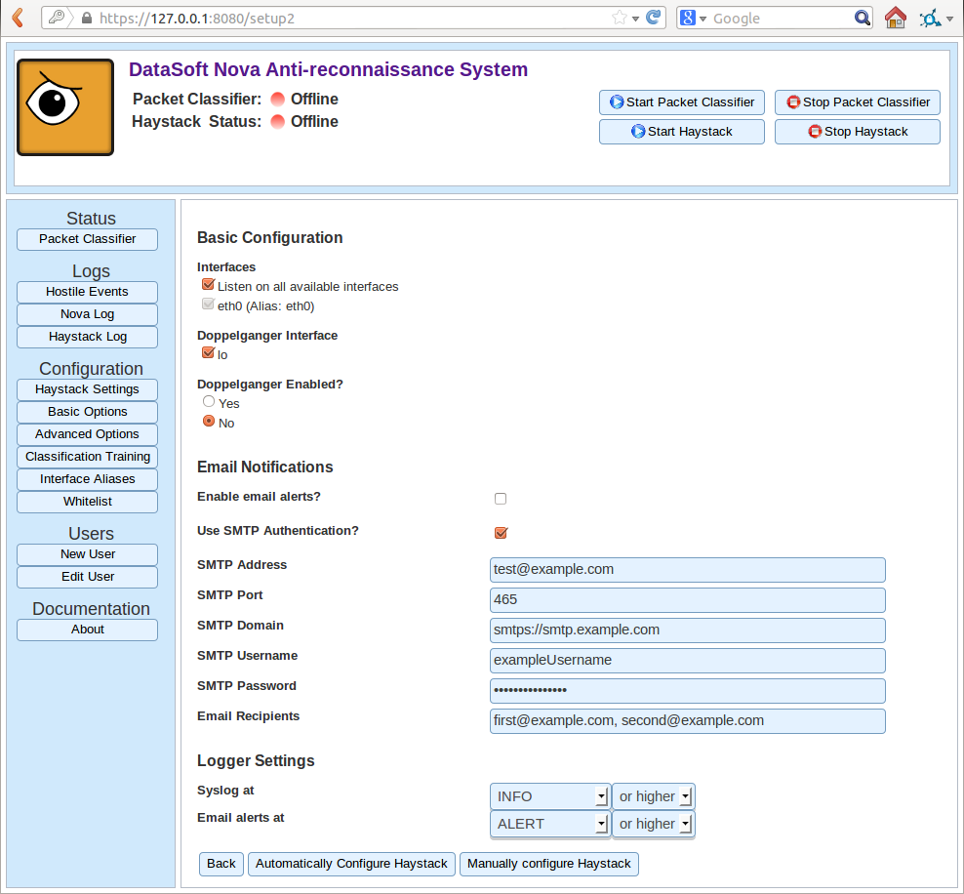Figure 5: Basic Options

Email Notifications
Nova is able to send you email alerts to tell you when an attacker has been detected by the system. Whenever a new hostile suspect is found, an email will be generated to the address(es) listed in the fields below, using the given SMTP settings.
- Enable Email Alerts
This checkbox lets you enable or disable the sending of email alerts.
- Use SMTP Authentication
Use an authenticated SMTP server, over a secure port
- SMTP Address
The email address that messages will be sent from
- SMTP Port
The TCP port on which to contact the server. This will be set to the normal default for secure SMTP (465) or insecure (25), but can be overridden
- SMTP Domain
The URL of the SMTP server itself
- SMTP Username
The username of the account on the SMTP server to log in as
- SMTP Password
The password of the account on the SMPT server to log in as
- Email Recipients
A comma separated list of email addresses to send email alerts to
When you are finished setting the Basic Options, you can choose to continue on by either manually or automatically configuring the Haystack. For more information on these options, see Section 2.4.

Haystack Settings
The Haystack is at the heart of the concept and effectiveness behind Nova. This is a large set of virtual decoy machines that you deploy onto your network to protect you real assets. Since there are potentially thousands of these decoy machines, setting them up individually can be an difficult and time consuming process. They all have a deep amount of configurability from Operating System, open and closed ports, uptime, running services, etc... For this reason, Nova has the ability to automatically create a Haystack for you that looks similar your protected network. If you would like to use this feature, press the Automatically Configure Haystack button at the end of the Basic Options page. For manual configuration, press the Manually Configure Haystack button.
Naturally, you will be able to manually tinker with the settings later no matter what option you choose now.

Haystack Autoconfig
The Autoconfig feature will perform a network scan of where you point it and read in what the network looks like. It will then generate a Haystack automatically for you that is similar to yours. This way the decoys don't “stand out” in your network. The goal here is to make it hard for attackers to figure out what's real and what's fake, so blending in with your network is a good thing.
NOTE: This feature will perform an Nmap scan of the networks you tell it to. This may sometimes cause alerts amongst other security devices on your network. OS scan packets, for example, are often in a firewall's rule of hostile traffic.
The following describes the options when automatically configuring your Haystack.

New Haystack
As you have not yet set up any Haystacks, you will need to make a new one. So just leave this option as check marked.

New Haystack Name
Quasar is able to remember more than one Haystack that you create. So you can tinker around with one and save it, while actively using another. You will then be able to switch between them easily later. In order to remember which one you're creating now, give it a name in the text box.
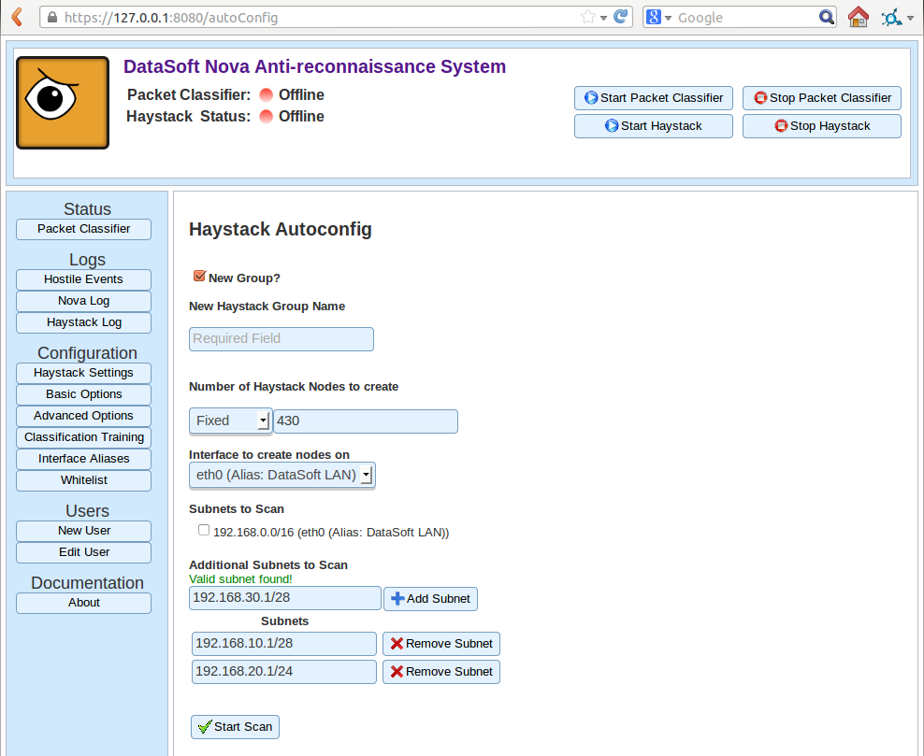Figure 6: Auto-configuration Options

Number of Haystack Nodes to Create
The size of your Haystack is the first important choice that you need to make. How many virtual decoys do you want? There are three primary ways of choosing this:
- Fixed
This option allows you to specify an absolute number of decoys that will be allocated IP addresses using DHCP.
- Ratio
This option will give you an amount of decoys relative to the number of real machines that were scanned, using DHCP. This is expressed as a ratio of 1:X. For example, entering “1” will give you a 1:1 ratio of decoys to real. Entering “.75” will give you fewer. (1 decoy for every 1.33 real machines)
- IP Range
This option will statically allocate IP addresses so as to fill the range supplied. IE: “10.10.0.1-10.10.0.150” will give you 150 decoys in the range described.
NOTE: The decoys will obey the address you give them under this option. So you will want to be sure that there is not an IP conflicts in the specified range.

Interface to Create Nodes On
For DHCP allocated nodes, they need to be told which Ethernet interface to request their addresses on. For instance, you may have 3 different DHCP servers on 3 different networks connected to Nova. The system needs to be told which of these servers to obtain the addresses from.

Subnets to Scan
Here is where you can choose from some pre-canned subnets, chosen from the settings of your underlying network. You can include them in the scan or not by checking the box next to their respective names. Checking one of these boxes will tell Nova to scan that whole subnet when auto-configuring.

Additional Subnets to Scan
In this box, you can supply additional networks to scan during the auto-configuration. These are specified in CIDR notation, IE: 192.168.5.0/24
NOTE: Trying to scan a very large subnet (/16 or larger) can take a potentially long time. If you do want to scan such a network, then just be patient while the scan is going on. You will be able to see its progress after you start it.

Start Scanning
When you're ready, hit the “Start Scan” button to initiate the auto-configuration.

Nova Status
Nova status

Current Suspects
The Suspects Page shows the list of all network entities that the Nova system has seen. From the perspective of Nova, anything that has an IP address is a “suspect” and is possibly hostile. This page gives you an overview of these suspects. Each row in the table depicted in Figure 7 represent a single network suspect that Nova has seen.
By default, suspects are sorted by their classification value. This is a percentage between 0% (almost surely benign) and 100% (almost surely hostile). To help aid visually, a color gradient is added to this column to depict the classification.

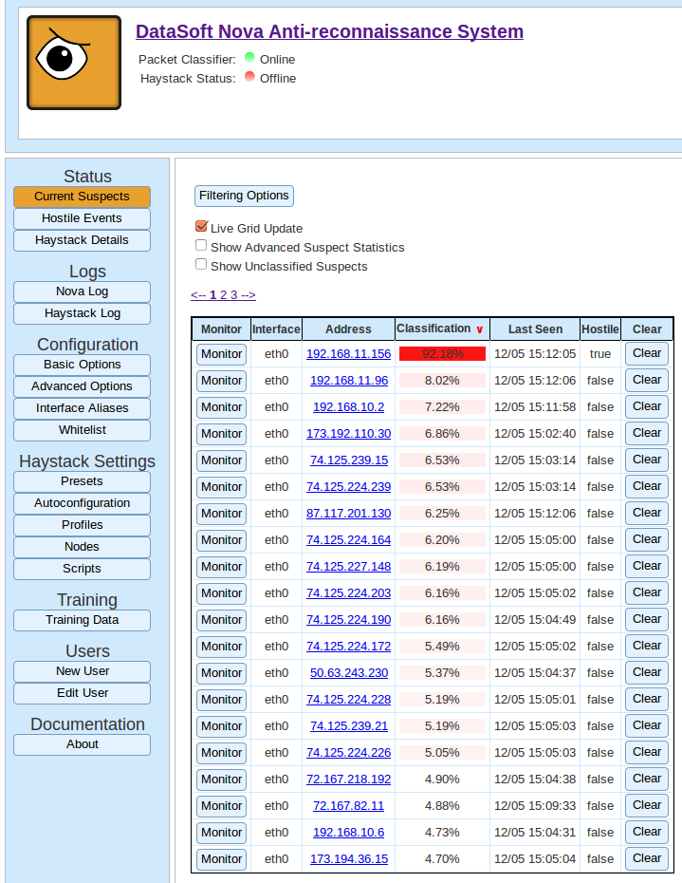Figure 7: Suspects Page
Other columns in the table include:
- column
- column
- column

Hostile Events
The hostile events page describes any recent hostile activity on your network. Every entry in the table represents a suspect being classified as hostile, and some traffic statistics about that suspect which was used to make that classification.
Figure 8: Hostile Events Page

Haystack Details
The Haystack Details page gives you a summary of the current status of the Haystack and its composition.

Figure 9: Haystack Status

Haystack Settings
TODO: Description for Haystack Settings

Presets
TODO: Presets description

Autoconfiguration
TODO: Autoconfig description

Profiles
TODO: profile editing

Nodes
TODO: Nodes

Scripts
TODO: scripts

Configuring Nova
This section describes pages which allow you to set global configurations on Nova.

Basic Configuration Options
TODO: Description of basic configuration options
Figure 10: Basic Configuration

Advanced Configuration Options

TODO: advanced configuration description

Interface Aliases
TODO: interface alias description

Whitelist
TODO: whitelist description

Training
TODO: description

Training Data

Logs
TODO: description

Nova Logs
TODO: Description

Haystack Log
TODO: log

Users
TODO: description

New User
TODO: new user

Edit User
TODO: description

Documentation
TODO: description

About
TODO: Description

